

4069 AND

4081 OR

4071 XOR 0 0 / 1 1 = 0 0 1 / 1 0 = 1

DM 7403

SN 7403

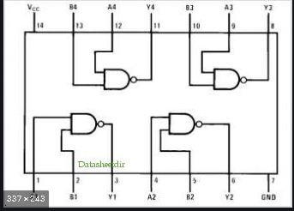

CD 4071

